

ORDERING & DISPATCH
CUT-OFF TIMES

The Time Schedules described below as “Cut-Off Times” refer to a specific time of a regular working day that a group of confirmed items, a confirmed order, will be finalized and forwarded to the warehouse for picking and packing, invoicing and then dispatch to the specified Courier Service carrier.

This process is called “closing” (the order), it is initiated with the customer’s command and it refers only to items that are already available in-stock. After this command is given, the order is swiftly forwarded to the warehouse for processing. From that moment on it is impossible for any items to be removed from it. You may submit additional items to be included to the initial shipment but only if you fall inside the “additional Order Cut-Off Time” and only if the initial items have not already been invoiced.

“Cut-Off Times” only apply to shipments dispatching on the same day with order “closing” using any international forwarded such as UPS, TNT, DHL, FedEx etc., their purpose being to ensure that all shipments make it to their final destination according to schedule. If these schedules are kept, Enarxis Dynamic Media can guarantee you that you order will be dispatched on the same day of your order “closing”. For order “closing” effected after the current day’s “Cut-Off Time”, this guarantee is transferred to the next working day.

Α. Main Order “Closing” Cut-Off Time.
The Cut-Off time for the main order that is to be shipped by Courier Service on the same day with the order “closing” is set to 16:00 Local Time. As a consequence, for every order that is not particularly large in size and may require special handling, Enarxis can guarantee same day dispatch. If for any other reason this guarantee can’t be provided, you will be informed in order to assess and decide as to the proper handling of your order.

B. Supplementary Order “Closing” Cut-Off Time.
The Cut-Off time for any supplementary order(s) that is/are to be shipped along with the main one by Courier Service on the same day with the order “closing” is set to 17:00 Local Time, provided that the latter is not already invoiced. To delay early invoicing of your main order, you may inform your sales representative that it is likely to send a supplementary order within the set time schedule in order for him to hold invoicing until you send that order.
IMPORTANT NOTICE: Please be aware that in the case of a supplementary to the main one order, this will be packed in a separate carton independently of pieces, weight or volume. No exceptions can be made…!!!

After these Cut-Off times, you may still log-in your orders and instruct for “closing” and shipping. Enarxis staff will exercise its best efforts to serve your order but without any guarantee for same day dispatch.

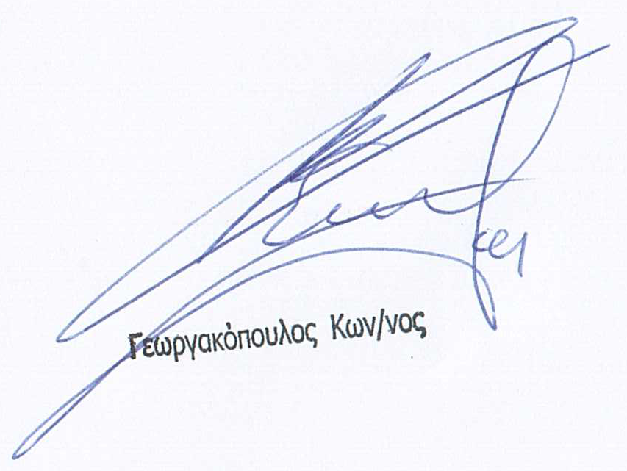
Sincerely,

Georgakopoulos J. Constantine
Managing Director.

