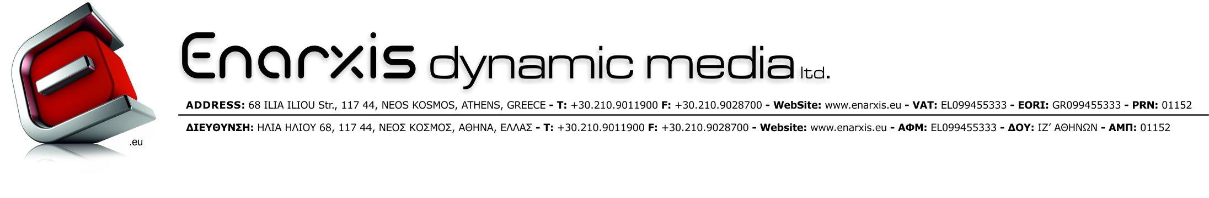

INTERNATIONAL INCOMING
VALUE TRANSFERS
COMPLIANCE POLICY

Enarxis Dynamic Media Ltd. (from now on “Enarxis”), acknowledges the need to voluntarily comply with domestic and international laws and regulations (Domestic Auditing Regulations, European Directives, OECD FATF Recommendations, Bank of Greece Guidelines) regarding international commercial value transfer practices thus protecting itself, its clients and overall partners against any legal risk that may arise in the event of value transfers that may contain indications “Red Tags” of using the international banking system for illicit transactions.

In order to fill that need, Enarxis has set-up the at-hand Incoming Value Transfers Policy to provide the means to sufficiently document it’s transactions against any requirements or requests posed from the co-operating domestic banking institutions to which all of its incoming wire transfers are deposited as well as against any auditing procedures from the local Tax Authorities. This policy is applicable to all incoming wire transfers originating from a country other than Greece and will be strictly kept without any exceptions.

According to this policy, all incoming wire transfers that are meant to pay for goods sold from Enarxis or services rendered by it, must…
- Have complete originator information thus Sender’s Full Name, Address, Account Number and Sending Bank’s Name or BIC as well as Beneficiary’s Name and Bank Account. If Sender’s account No. or Address is absent a unique reference no is enough.
- The Sender’s Name or Company Title must be the same with the Customer’s name to which the goods or services were or will be invoiced to. In the opposite case, the customer is obliged to sign a declaration stating that the funds originating from a specific company other than the one to which the goods or services were or are to be invoiced are meant to pay for another company’s invoice(s). If the customer eventually fails to present this declaration fully filled-in, signed and stamped, invoicing will be denied and all the funds returned.

INTERNATIONAL VALUE TRANSFER
DECLARATION REGARDING
IT’S FINAL BENEFICIARY

Today, the ….…/….…/2013, I the undersigned …………………………………………………, representing the company …………………………………………………………..., affirm that I have transferred the amount of ………………….…..……….. in the currency of ……….………….. from my bank ……………………………………..……………………………. to Enarxis Dynamic Media Ltd.

The aforementioned wire transfer is meant to pay for invoice(s), pro-forma invoice(s) or purchase order(s) having the code(s) ………………………...…….…………………….. which are or will be issued to the company …………………………………………………… to which I and the Sending Company are also directly related.

Additionally I am also authorizing Enarxis Dynamic Media Ltd. to record this incoming wire transfer in its accounting books as a payment originating from the aforementioned invoiced company.

Finally, I confirm that the wire transfer sending company has no further claim for the funds mentioned above against Enarxis Dynamic Media Ltd. from the time the goods are invoiced to the invoicing company.

Signed,

Please fill-in the name of the company from which the wire transfer originated from.
Please fill-in the currency of the wire transfer.
Please fill-in the originating bank’s name.
Please fill-in the name of the company to which the invoices paid by the incoming wire transfer will be issued.
Please fill-in your full name and place your signature and company stamp.

